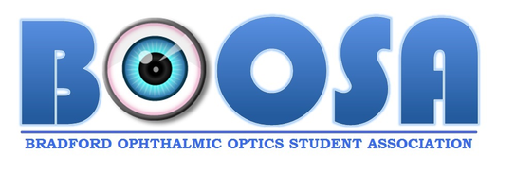

BRADFORD OPTHALMIC OPTICS STUDENT ASSOCIATION
MEETING MINUTES- 03/12/2018 11:00 - 13:00

- CALL TO ORDER
Umayr Zahid called to order the BOOSA meeting at 11:00 on the 13th of December 2018.

- ROLL CALL
The following people from the committee were present; Umayr Zahid (President), Asmaa Patel (Secretary), Mohammed Momoniat (Vice President) and Haneen Amer (Public relations officer). The following non-exec members present were Salim Alam, Hassan Rehman, Saarah Seedat, Humaira Bham, Hager Yonis, Zainab Khalid and Aadil Saeed.

- APPROVAL OF MINUTES FROM LAST MEETING
Asmaa Patel read the minutes from the last meeting and approved them as read.

- AGENDA
BOOSA Annual General Meeting (AGM)
- Finances for the year: The team had a look at the total spendature, income and revenue and conquered that the finances are all well controlled and maintained with no issues this year.
- Events that were organised in the past year: The team has no serious issues with how the planning of these events such as the Eyeball, Bowling or Lasertag was conducted but did agree that certain things could be improved upon. Overall, every event planned was a success, especially the Eyeball 2018.
- Quality Mark: The team reviewed our current progress with the Quality mark and are pleased with the progress that BOOSA have made. Our target is to reach Gold and are only about 20 points away with second semester still to go.
- Eyeball 2019 Planning: The team spent half of the meeting finalising certain elements of the Eyeball 2019. Date, time, venue, caterer, DJ, food menu, choc fountain and photobooth was all confirmed.

- ADJOURNMENT
Umayr Zahid adjourned the meeting at 13:00 minutes, submitted by: Asmaa Patel. Minutes approved by: Mohammed Momoniat and Haneen Amer

